**PROJECT NAME: AI QUIZ CRAFT – Harnessing BERT Extractive Summarization, WordNet, and ConceptNet for MCQ Generation**

**PROBLEM STATEMENT:**

Design an AI-based system capable of generating multiple-choice questions (MCQs) from any given content or news article. The system should employ advanced natural language processing techniques, including BERT Extractive Summarization, WordNet, and ConceptNet, to analyze the text, extract relevant information, and formulate questions that test the reader's understanding of the material. The generated MCQs should cover various aspects of the content, including key concepts, relationships between entities, and contextual understanding. The goal is to develop a robust and accurate system that can efficiently generate high-quality MCQs to aid in comprehension assessment and educational content creation across diverse domains.

**PROPOSED SYSTEM:**

The proposed system combines BERT Extractive Summarization with WordNet and ConceptNet integration to achieve a comprehensive understanding of textual content.

By leveraging these algorithms together, the system can analyze text, extract key concepts, understand semantic relationships, and generate meaningful multiple-choice questions that assess comprehension effectively.

**1. BERT Extractive Summarization**

**Algorithm Overview**:

* BERT (Bidirectional Encoder Representations from Transformers) is a state-of-the-art NLP model developed by Google.
* BERT Extractive Summarization involves fine-tuning pre-trained BERT models to generate concise summaries of input text.

**Working Principle**:

* + BERT models are trained on large corpora of text data to understand the contextual relationships between words.
  + During summarization, the model identifies important sentences in the input text based on their relevance to the overall context.

**Benefits**:

* + BERT Extractive Summarization produces summaries that preserve the key information and main ideas of the original text.
  + By leveraging contextual embeddings, it captures nuances and subtle meanings present in the text.

**2. WordNet Integration**

**Algorithm Overview**:

* WordNet is a lexical database that organizes words into synsets (sets of synonyms).
* It provides structured information about word meanings, relationships, and semantic similarity.

**Working Principle**:

* + WordNet offers a hierarchy of word relationships, such as hypernyms (more general terms), hyponyms (more specific terms), and meronyms (part-whole relationships).
  + By analyzing word relationships within WordNet, the system gains semantic understanding and can infer connections between concepts.

**Benefits**:

* + Integrating WordNet enhances the system's ability to comprehend the meaning of words and their contextual significance.
  + It enables the generation of more accurate and contextually relevant multiple-choice questions.

**3. ConceptNet Integration**

**Algorithm Overview**:

* ConceptNet is a large-scale knowledge graph that represents general human knowledge as a network of concepts and relationships.
* It contains structured information about various concepts and their interconnections.

**Working Principle**:

* ConceptNet provides a rich source of background knowledge that can supplement the understanding of textual content.
* By querying ConceptNet, the system can access information about common sense relationships, factual knowledge, and conceptual associations.

**Benefits**:

* Integrating ConceptNet enriches the system's semantic analysis capabilities by incorporating external knowledge beyond the input text.
* It facilitates the generation of more contextually relevant and conceptually diverse multiple-choice questions.

**SYSTEM APPROACH: HARDWARE AND SOFTWARE REQUIREMENT**

Hardware Requirements:

**Processor**:The system can run on a variety of processors, including CPUs and GPUs. For optimal performance, a CPU with multiple cores or a GPU with CUDA support can be beneficial, especially for large-scale text processing tasks.

**Memory (RAM)**: Sufficient RAM is essential to handle the computational requirements of natural language processing tasks. A minimum of 8GB RAM is recommended, although higher RAM configurations may be advantageous for processing larger datasets.

**Storage**: Adequate storage space is required to store input data, pre-trained models, and intermediate results. Solid-state drives (SSDs) or high-speed storage devices can help improve processing efficiency.

Software Requirements:

**Google Colab**: The system is developed using Python programming language. The system has been tested and developed using Google Colab, a cloud-based Jupyter notebook environment. Google Colab provides free access to GPU resources, which can significantly speed up computation for NLP tasks.

**Libraries**:

**Gensim**: A Python library for topic modeling, document similarity analysis, and other natural language processing tasks.

**pke**: A Python library for key-phrase extraction.

**spaCy**: An open-source NLP library used for text processing, including tokenization, POS tagging, and dependency parsing.

**bert-extractive-summarizer**: A library for BERT-based extractive text summarization.

**NLTK**: The Natural Language Toolkit, providing various NLP functionalities such as tokenization, stemming, and word sense disambiguation.

**pywsd**: A Python library for Word Sense Disambiguation (WSD), which can be useful for semantic analysis tasks.

**Additional Dependencies**:

**spaCy Model**: The English language model for spaCy (**en_core_web_sm**) is required and can be downloaded using **!python -m spacy download en**.

**BERT Models**: Pre-trained BERT models are utilized by the **bert-extractive-summarizer** library. These models are downloaded automatically during installation.

**ALGORITHM FLOW:**

**Step 1: Text Analysis and Preprocessing**

**Input Text**:

Users provide textual content or articles to the system.

**Preprocessing**:

Text undergoes preprocessing steps, including tokenization, lowercasing, and punctuation removal.

Stop words are removed to filter out common, less informative words.

**Step 2: BERT Extractive Summarization**

**BERT Extractive Summarization**:

BERT models analyze the preprocessed text to identify the most relevant sentences.

Contextual embeddings are computed for each token, and sentence embeddings are generated based on these embeddings.

Sentences with the highest importance scores are selected to create a summary of the text.

**Step 3: Semantic Analysis with WordNet and ConceptNet**

**Semantic Analysis**:

WordNet and ConceptNet are utilized to analyze semantic relationships and enrich the system's understanding of the text.

WordNet provides structured information about word meanings and relationships, such as synonyms, hypernyms, and hyponyms.

ConceptNet offers background knowledge and factual information relevant to the text.

**Step 4: MCQ Generation**

**MCQ Generation**:

Based on the summarized text and semantic analysis results, the system formulates multiple-choice questions (MCQs).

MCQs cover various aspects of the content, including key concepts, relationships between entities, and contextual understanding.

Plausible answer options are generated for each question to ensure that distractors are relevant and plausible.

**DEPLOYMENT:**

**GitHub Repository**: The trained model and associated code are deployed into a GitHub repository for easy access and sharing. Users can clone or fork the repository to access the code and utilize the trained model.

**Setup Environment and Run Code**: Instructions are provided in the repository's README file on how to set up the environment and run the code. Users are guided through the process of installing necessary dependencies, configuring the environment, and executing the code.

**Documentation and README File**: A comprehensive documentation and README file are included in the repository to explain the project, algorithm, and deployment process. The README file provides detailed instructions, including installation steps, usage guidelines, and information about the algorithm used for MCQ generation.

**Accessing the Repository**: Link to the GitHub repository where the trained model and code are deployed. Users can access the repository to download the code, documentation, and trained model. The README file is highlighted as a crucial resource for setup and usage guidelines.

**Setting Up the Environment**: Provide step-by-step instructions for setting up the environment to run the code. Include information about installing necessary dependencies and any additional configuration steps required for successful execution.

**Running the Code**: Explain how to execute the code to generate MCQs from textual content. Provide guidance on providing input data and any specific formatting requirements. Encourage users to explore the repository, refer to the documentation, and contribute to the project if interested.

**RESULTS:**

**BERT Extractive Summarizer**

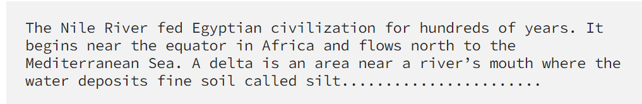

**Extract Keywords**

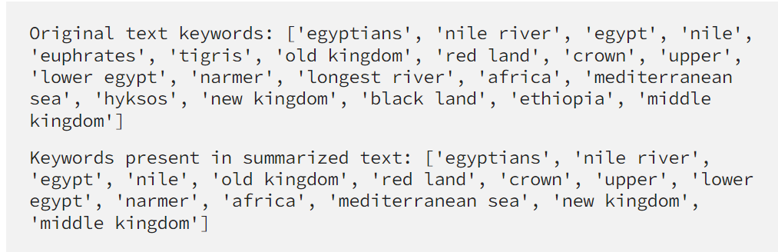

**Sentence Mapping**

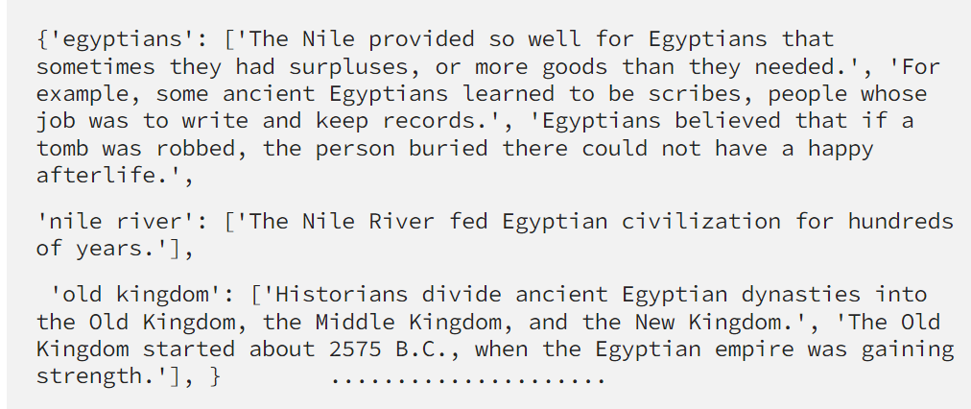

**Generate MCQ**

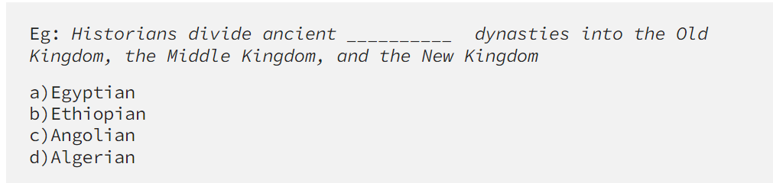

**CONCLUSION:**

AiQuizCraft revolutionizes educational content creation by automating MCQ generation from text. Leveraging state-of-the-art NLP techniques like BERT Extractive Summarization and semantic analysis with WordNet and ConceptNet, it efficiently generates engaging quizzes and assessments. With its user-friendly deployment via GitHub and comprehensive documentation, AiQuizCraft empowers educators to enhance learning experiences, promote personalized learning, and improve educational outcomes. This innovative tool represents a significant advancement in educational technology, poised to transform comprehension assessment and educational content creation.

Top of Form